**From:** Amir Ben. Shalom   
**Sent:** Monday, January 8, 2024 1:49 PM  
**To:** JLCPCB Support‏ <support@jlcpcb.com>  
**Subject:** RE: PCBA order issue of 2843693A_SMT02401071546615_Y109 ----JLCPCB

Yes it is correct please start production

Amir B

**From:** JLCPCB Support <[support@jlcpcb.com](mailto:support@jlcpcb.com)>   
**Sent:** Monday, January 8, 2024 12:53 PM  
**To:** Amir Ben. Shalom‏ <[amirb@mada.org.il](mailto:amirb@mada.org.il)>  
**Subject:** Re: PCBA order issue of 2843693A_SMT02401071546615_Y109 ----JLCPCB

Hi there,

So sorry for the late reply.

We have corrected them and updated the2D DFM.

Could you please kindly check again? Is that correct?

Shall we start production?

﻿

.



|  |  |
| --- | --- |
| Doris mo | |
|  | |
|  |  |
| Web: | [JLCPCB.COM](http://JLCPCB.COM) |
| Email: | [doris@jlcpcb.com](mailto:%7b%25user.email%25) |

How would you rate my reply?  
[Great](https://secure.helpscout.net/satisfaction/332317884/record/7416591149/1/)    [Okay](https://secure.helpscout.net/satisfaction/332317884/record/7416591149/2/)    [Not Good](https://secure.helpscout.net/satisfaction/332317884/record/7416591149/3/)

{#HS:2473432413-1138137#} https://secure.helpscout.net/notification/convo/read/2473432413/7416591149/

On Mon, Jan 8, 2024 at 2:05 PM HKT, Amir Ben. Shalom <[amirb@mada.org.il](mailto:amirb@mada.org.il)> wrote:

Dear Doris.  
  
Thanks for your mail and sorry for missing this.  
  
Please check if you can unpopulated only  
  
ACM,BCM,CCM,DCM,ECM,FCM,GCM,HCM  
  
(C1 not touch any other parts)  
  
And populate  
  
BDM,CDM,DDM,EDM,FDM,GDM,HDM,ADM  
  
Attached is new BOM without  
  
ACM,BCM,CCM,DCM,ECM,FCM,GCM,HCM  
  
(C1 not touch any other parts)  
  
If you can't - please unpopulated all parts you mention.  
  
Anyway, not need any refunds, transaction fee will be more than the refunds for both sides J, and I really appreciate the grate work you are doing and the value it give to anyone who deal with electronics for living, hobby or (most important..) education.  
  
Dr Amir Ben-Shalom  
  
Bloomfield Science museum Jerusalem  
  
  
  
cid:image005.gif@01D8A673.0945AA40  
  
cid:image006.png@01D8A673.0945AA40  
  
Get [Outlook for Android](https://aka.ms/AAb9ysg)

On Mon, Jan 8, 2024 at 8:33 AM HKT, JLCPCB Support <[support@jlcpcb.com](mailto:support@jlcpcb.com)> wrote:

﻿Hello,

Well got your order with many thanks.

Sorry to bother you, but there is one thing that we want to confirm with you about your SMT order before proceeding.

The spacing between parts of C1、HCM、ACM、GCM、BCM、FCM、ECM、CCM、DCM。HDM、ADM、GDM、BDM、FDM、CDM、EDM、DDM is too small to place them, they will touch other parts, so we can't solder them.

There are 2 option for reference.

A: we leave them unpopulated and refund the cost.

B: we cancel this order and you change the gerber file.

Which case would you like?

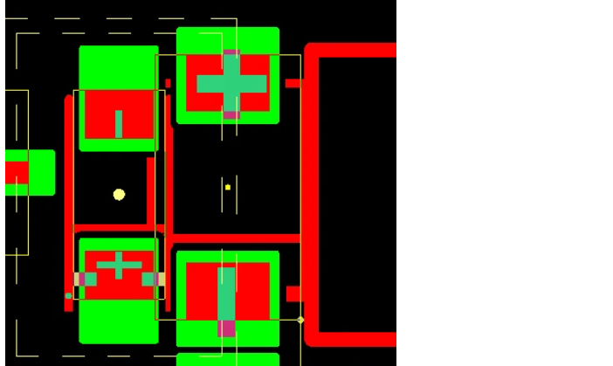

Your early reply will be highly appreciated, thank you so much!

.



|  |  |
| --- | --- |
| Doris mo | |
|  | |
|  |  |
| Web: | [JLCPCB.COM](http://JLCPCB.COM) |
| Email: | [doris@jlcpcb.com](mailto:%7b%25user.email%25) |

**From:** Amir Ben. Shalom <amirb@mada.org.il>   
**Sent:** Monday, January 8, 2024 8:05 AM  
**To:** JLCPCB Support‏ <support@jlcpcb.com>  
**Subject:** Re: PCBA order issue of 2843693A_SMT02401071546615_Y109 ----JLCPCB

Dear Doris.

Thanks for your mail and sorry for missing this.

Please check if you can unpopulated only

ACM,BCM,CCM,DCM,ECM,FCM,GCM,HCM

(C1 not touch any other parts)

And populate

BDM,CDM,DDM,EDM,FDM,GDM,HDM,ADM

Attached is  new BOM without

ACM,BCM,CCM,DCM,ECM,FCM,GCM,HCM

(C1 not touch any other parts)

If you can't  - please unpopulated all parts you mention.

Anyway,  not need any refunds,  transaction fee will be more than the refunds for both sides ☺,  and I really appreciate the grate work you are doing and the value it give to anyone who deal with electronics for living, hobby or (most important..) education.

Dr Amir Ben-Shalom

Bloomfield Science museum Jerusalem



cid:image005.gif@01D8A673.0945AA40

cid:image006.png@01D8A673.0945AA40

Get [Outlook for Android](https://aka.ms/AAb9ysg)

**From:** JLCPCB Support <[support@jlcpcb.com](mailto:support@jlcpcb.com)>  
**Sent:** Monday, January 8, 2024 2:34:05 AM  
**To:** Amir Ben. Shalom <[amirb@mada.org.il](mailto:amirb@mada.org.il)>  
**Subject:** PCBA order issue of 2843693A_SMT02401071546615_Y109 ----JLCPCB

﻿Hello,

Well got your order with many thanks.

Sorry to bother you, but there is one thing that we want to confirm with you about your SMT order before proceeding.

The spacing between parts of C1、HCM、ACM、GCM、BCM、FCM、ECM、CCM、DCM。HDM、ADM、GDM、BDM、FDM、CDM、EDM、DDM is too small to place them, they will touch other parts, so we can't solder them.

There are 2 option for reference.

A: we leave them unpopulated and refund the cost.

B: we cancel this order and you change the gerber file.

Which case would you like?



Your early reply will be highly appreciated, thank you so much!

.



|  |  |
| --- | --- |
| Doris mo | |
|  | |
|  |  |
| Web: | [JLCPCB.COM](http://JLCPCB.COM) |
| Email: | [doris@jlcpcb.com](mailto:%7b%25user.email%25) |

How would you rate my reply?  
[Great](https://secure.helpscout.net/satisfaction/332317884/record/7415641377/1/)    [Okay](https://secure.helpscout.net/satisfaction/332317884/record/7415641377/2/)    [Not Good](https://secure.helpscout.net/satisfaction/332317884/record/7415641377/3/)

{#HS:2473432413-1138137#} https://secure.helpscout.net/notification/convo/read/2473432413/7415641377/